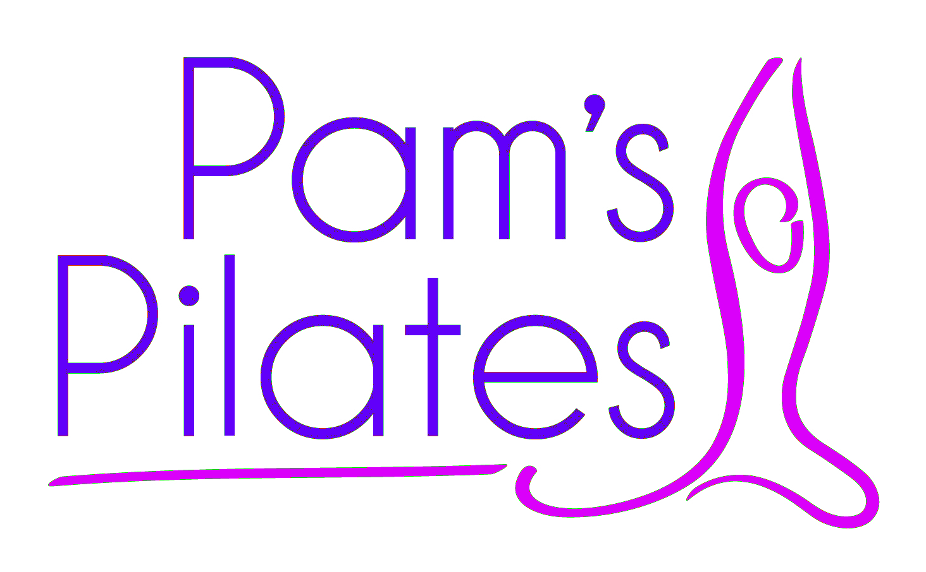

OCTOBER 2015 NEWSLETTER

MON 2 NOV – MON 7 DEC
TUES 3 NOV – TUES 8 DEC
WED 4 NOV – WED 9 DEC

6 WEEKS = £48.00

Exciting News
I am starting an evening class at Chetton Village Hall on Monday evenings at 7.00 pm. The class is full at present.

Exercises to practice at home
I am going to provide you with a folder containing exercises that you can practice at home during the holidays. My aim is to complete it by Easter 2016.

Conditioning your feet
If you would like a chiropody experience for your feet I can recommend:
Mrs Wendy Bloomfield – 01746 763004, Feet First, 64 Whitburn St.

PILATES CHRISTMAS PARTY
THURSDAY 3RD DECEMBER – THE DOWN INN 7.30 PM

Please make cheques payable to Pam’s Pilates.
or make a payment to:

Intelligent Finance Sort Code: 119100 Account Number 02889122
Ref: Your surname
Pam Downing
Pam@pamspilates.com
07891 387701
www.pdowning@dbkltd.com

